**Project Design Phase-II**

**Technology Stack (Architecture & Stack)**

| Date | 17 October 2022 |
| --- | --- |
| Team ID | PNT2022TMID32618 |
| Project Name | Plasma Donor Application |
| Maximum Marks | 4 Marks |

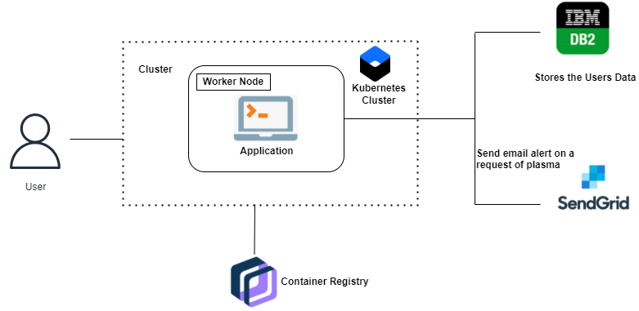

**Table-1 : Components & Technologies:**

| **S.No** | **Component** | **Description** | **Technology** |
| --- | --- | --- | --- |
| 1. | User Interface | The user interacts with the application eg.website UI | HTML, CSS, JavaScript , Angular Js ,React Js. |
| 2. | Application Logic-1 | New user registers for the application by providing the email account | Java / Python , Flask,HTML,CSS |
| 3. | Application Logic-2 | Registered Users login into the application by  providing the username and password. | IBM DB2, Flask,HTML,CSS |
| 4. | Application Logic-3 | Stats page displays the number of  donors available for each blood group and the  count available | IBM Watson Assistant |
| 5. | Application Logic-4 | A request page that collects the recipients information such as name,contact number,mail ID and the blood group  needed which the request is sent to  a donor whose blood group matches  with the recipients. | SendGrid,HTML,CSS |
| 6. | Database | String for name ,characters for mail ID,integers for contact number. | MySQL. |
| 7. | Cloud Database | Database Service on Cloud | IBM DB2 |
| 8. | External API-1 | Sending request to the donors. | Sendgrid |
| 9. | Infrastructure  (Server / Cloud) | Application deployment | Kubernetes. |

**Table-2: Application Characteristics:**

| **S.No** | **Characteristics** | **Description** | **Technology** |
| --- | --- | --- | --- |
|  | Open-Source Frameworks | List the open-source frameworks used | Docker, Kubernetes |
|  | Security Implementations | List all the security / access controls implemented, use of firewalls etc. | Transport Layer  Security (TLS),Doctor Content  Trust(DCT),. |
|  | Scalable Architecture | Justify the scalability of architecture (3 – tier, Micro-services) | Docker |
|  | Availability | Justify the availability of application (e.g. use of load balancers, distributed servers etc.) | kubernetes |
|  | Performance | Design consideration for the performance of the application (number of requests per sec, use of Cache, use of CDN’s) etc. | Docker and kubernetes |